Aim
To develop an Android application using Kotlin that accepts two numbers from the user, performs addition, and displays the result when the Add button is clicked.

Algorithm
- Start the application.
- Initialize the UI components:
  - First Number EditText
  - Second Number EditText
  - Add Button
  - Result TextView
- Enter the first number.
- Enter the second number.
- Click the Add button.
- Read the values entered in both EditText fields.
- Convert the input values into numeric data types (Double/Integer).
- Add the two numbers.
- Display the sum in the Result TextView.
- Make the Result TextView visible.
- Stop.

Kotlin java
Activity_main_kt rightclick xmllayout Activity_main_xml

Activity_main_xml
<?xml version="1.0" encoding="utf-8"?>
<LinearLayout xmlns:android="http://schemas.android.com/apk/res/android"
android:layout_width="match_parent"
android:layout_height="match_parent"
android:orientation="vertical">
<TextView
android:id="@+id/textView1"
android:layout_width="150dp"
android:layout_height="48dp"
android:layout_marginStart="10dp"
android:layout_marginTop="52dp"
android:gravity="center_vertical"
android:text="@string/first_textView"
android:textSize="16sp" />
<EditText
android:id="@+id/first_number"
android:layout_width="150dp"
android:layout_height="48dp"
android:layout_marginTop="52dp"
android:autofillHints="no"
android:ems="10"
android:hint="@string/first_number_hint"
android:inputType="number"
android:textSize="16sp"/>
<TextView
android:id="@+id/textView2"
android:layout_width="150dp"
android:layout_height="48dp"
android:layout_marginStart="10dp"
android:layout_marginTop="8dp"
android:gravity="center_vertical"
android:text="@string/second_textView"
android:textSize="16sp" />
<EditText
android:id="@+id/second_number"
android:layout_width="175dp"
android:layout_height="48dp"
android:layout_marginTop="4dp"
android:layout_marginEnd="10dp"
android:ems="10"
android:hint="@string/second_number_hint"
android:importantForAutofill="no"
android:inputType="number"
android:textSize="16sp" />
<Button
android:id="@+id/button"
android:layout_width="139dp"
android:layout_height="57dp"
android:layout_marginTop="84dp"
android:text="@string/Button_value" />
<TextView
android:id="@+id/result"
android:layout_width="150dp"
android:layout_height="40dp"
android:layout_marginTop="88dp"
android:gravity="center"
android:text="@string/result"
android:textSize="16sp"
android:visibility="gone" />
<TextView
android:id="@+id/result_value"
android:layout_width="150dp"
android:layout_height="40dp"
android:gravity="center"
android:textSize="16sp"
android:visibility="gone"/>
</LinearLayout>

app > res > values > strings.xml
<resources>
<string name="app_name">My Applicationsamplefinal</string>
<string name="first_textView">First Number</string>
<string name="first_number_hint">Enter First Number</string>
<string name="second_textView">Second Number</string>
<string name="second_number_hint">Enter Second Number</string>
<string name="Button_value">Add</string>
<string name="result">Result</string>
</resources>
[versions]
agp = "8.13.2"
kotlin = "2.0.21"
coreKtx = "1.17.0"
junit = "4.13.2"
junitVersion = "1.3.0"
espressoCore = "3.7.0"
lifecycleRuntimeKtx = "2.9.4"
activityCompose = "1.13.0"
composeBom = "2024.09.00"

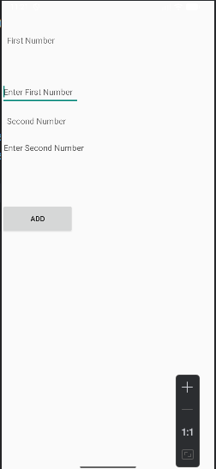

Result
The Android application was successfully developed and executed. The application accepts two numbers from the user and displays their sum when the Add button is pressed.

